fResponse to the Reviewers’ Comments for TIA-2026-IPCC-0540
Manuscript Title: Design and Implementation of a Non-coupled Integrated Transformer for a Two-phase Interleaved Flyback PFC Rectifier

Oct 26, 2026

Dear Editor,

We would like to express our sincere appreciation to the reviewers for their constructive and insightful comments on our manuscript. The manuscript was revised in accordance with point-by-point answers to all the questions and suggestions.
- We thank the reviewer for going through and agreeing with our response letter.
- Pages xx to xx correspond to Reviewer #2’s comments.
- Pages xx to xx correspond to Reviewer #3’s comments.
We revised the manuscript accordingly to the reviewers comments. In particular, we strengthened the literature review, clarified various explanations on the operational principle of the transformer, insights on the operation compared to a conventional, discrete implementation, and provided clarification on the experimental environment. We also updated the manuscript to improve clarity, consistency, and minor errors.

We hope the manuscript is now acceptable for publication.

Best Regards,
Sihoon Choi
Corresponding author,
Institute of Materials and Systems for Sustainability, Nagoya University
Email: choi.sihoon.w4@f.mail.nagoya-u.ac.jp

To Reviewer 2
We authors appreciate your valuable comments. The revised parts are indicated by red texts in the manuscript.
Comments to the Author
- The analytical explanation of the inherent DCM PFC mechanism is now clearer. However, the experimental verification remains insufficient. Please report measured PF and input-current THD, preferably at representative operating points.

We sincerely thank the reviewer for the valuable feedback and for acknowledging the clarity of our analytical explanation. We completely agree that the power factor $PF$ and input-current THD are critical metrics for PFC flyback rectifiers. However, because the inherent DCM PFC mechanism is already a well-known and established characteristic, our physical prototype was constructed without a grid-side EMI filter to focus on validating the magnetic decoupling of the proposed integrated core. We would also like to emphasize that the proposed magnetic integration does not alter the fundamental electrical principle of the converter. The inherent DCM PFC mechanism remains identical to that of a conventional topology utilizing discrete transformers. To rigorously demonstrate this, we have conducted a comprehensive simulation in PLECS with a standard differential-mode EMI filter ($L_{f}=100 \text{μ}\text{H}$, $C_{f}=1 \text{μ}\text{F}$) to obtain an accurate estimate.

Moreover, the proposed integrated transformer design was compared against a conventional, interleaved flyback baseline with two discrete cores. The cross-sectional area of these discrete cores was matched to the smaller outer leg of the proposed design ($A_{mo}=117.624{\text{ mm}}^{2}$). Both setups were assigned identical turns ratios (18:6) to the center leg of the proposed transformer, and air gaps were tuned to maintain the exact same nominal magnetizing inductance $L_{m}$. The magnetic path length was set to $66.21\text{ mm}$, and the air gap was set to 0.677 mm. Magnetic circuit models were utilized reflecting these parameters.

As shown in the table below, the proposed topology exhibits PF and input-current THD performance that is closely matched to the conventional discrete setup across the extremes of the operating range. This also confirms that the magnetic integration successfully preserves the PFC capability of the converter, given that PF > 0.97 across different operating points.

We have added PFC waveforms as well in various operating points for a visual reference for the reviewers. We have revised Section III completely to reflect these changes.

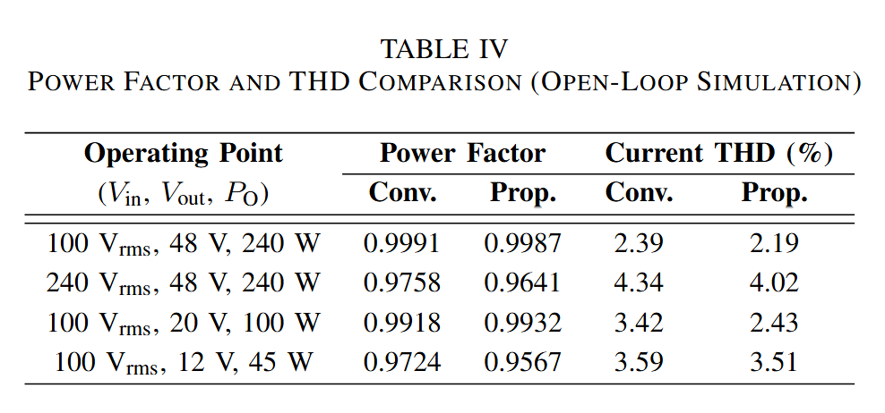
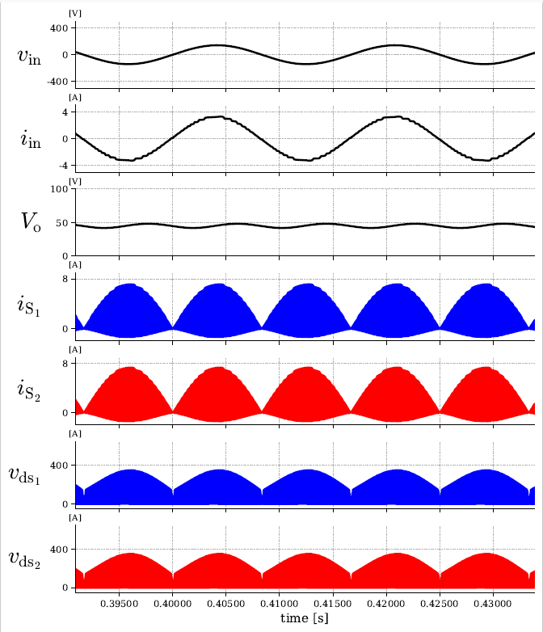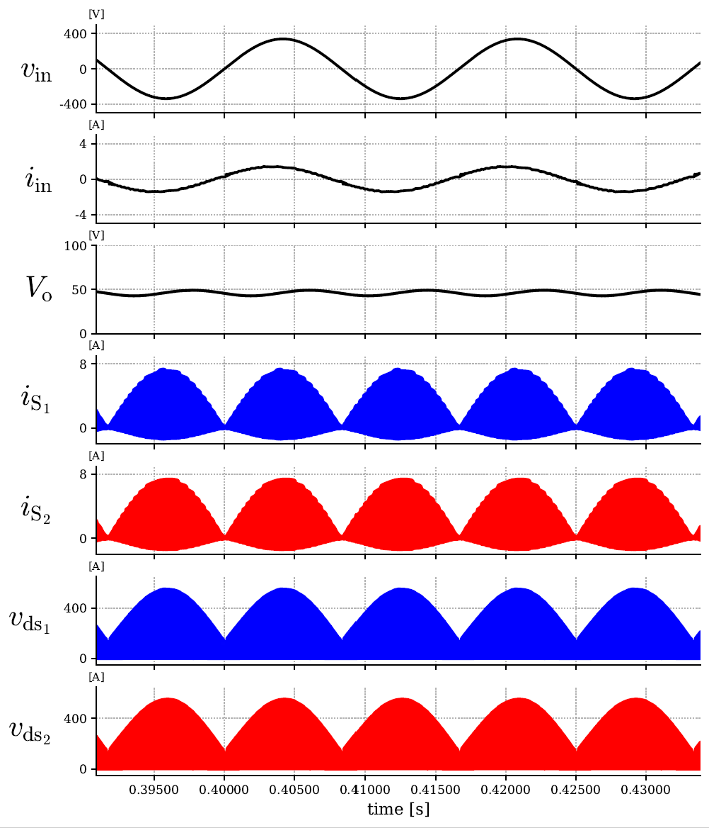
(a) (b)
Key PFC Waveforms showing v_{in}, v_{o}, i_{in}, i_{S1} and i_{S2}, and v_{ds1} and v_{ds2} with v_{in}, V_{out}, and P_{O} of: (a) 100 V_{rms}, 48 V, and 240 W and (b) 240 V_{rms}, 48 V, and 240 W.

- The added time-domain analysis satisfactorily explains the variation over one line cycle. Nevertheless, the manuscript should also clarify the variation of peak switch current and peak flux density when the RMS input voltage changes from 100 to 240 V, including the corresponding duty-cycle adjustment. Please identify the actual worst-case operating condition for switch current and core flux density.

We sincerely thank the reviewer for the valuable feedback and for acknowledging the clarity of our revised theoretical analysis. We completely agree that clarifying the component stresses across the universal input voltage range (100 V_{rms} to 240 V_{rms}) provides a more comprehensive understanding of the operating limits of the converter as a whole.
To address the variation in peak switch current and peak flux density, we must look at how the duty cycle $D$ adjusts with the RMS input voltage $V_{in}$. In a two-phase interleaved flyback PFC rectifier operating in DCM delivering constant output power $P_{o}$ under the same magnetizing inductance $L_{m}$ and same switching period $T_{s}$, $D$ is inversely proportional to the peak input voltage $V_{in_{max}}$ governed by (30) in the manuscript, which directly follows from [6]:
$$D=\frac{2}{V_{in_{max}}}\sqrt{\frac{0.5L_{m}P_{o}}{T_{s}}}$$
When $V_{in}$ increases from 100 V_{rms} to 240 V_{rms}, if a control loop is added, it will naturally decrease $D$ to maintain the same power transfer. If the adjusted $D$ is substituted into (2) and (4) in the manuscript, the absolute peak switch current $I_{S_{pk\left(max\right)}}$ which is at the peak of the AC line cycle, is given as:
$$I_{S_{pk\left(max\right)}}=\frac{V_{in_{max}}}{L_{m}}DT_{s}=\frac{V_{in_{max}}}{L_{m}}\left(\frac{2}{V_{in_{max}}}\sqrt{\frac{0.5L_{m}P_{o}}{T_{s}}}\right)T_{s}=2\sqrt{\frac{0.5P_{o}T_{s}}{L_{m}}}$$
As shown, the $V_{in_{max}}$ term mathematically cancels out. Moreover, from (3) and (5) in the manuscript, it follows that $I_{S_{pk\left(max\right)}}$and the absolute peak core flux density $B_{pk(max)}$remain theoretically constant across the entire 100 V to 240 V input range.
However, the worst-case operating condition for the current and the magnetic core is still the lowest input voltage at 100 V_{rms}. While the peak current remains constant, $D$ reaches its absolute maximum at 100 V_{rms}. Consequently, the RMS currents in the switches and transformer windings are maximized at 100 V_{rms}, leading to the highest conduction losses and winding losses. Factoring in the practical drop in efficiency at lower line voltages, the peak current will be slightly higher at 100 ${\text{V}}_{\text{rms}}$ to compensate for these losses, cementing it as the worst-case condition for current stress and core saturation. Conversely, the highest input voltage $240$ ${\text{V}}_{\text{rms}}$ is the worst-case condition for the switch voltage stress $V_{ds_{max}}$. We have added a new paragraph to the end of Section II-A to explicitly clarify this dynamic across the universal input voltage range and clearly identify the worst-case conditions for the readers.
The simulation and experimental waveforms in Fig. 12 and 17 respectively were taken under the worst-case operating conditions and show that the converter can operate without any problem with the integrated transformer. This is also clarified in the paper as follows.
Before revision | After revision
N/A | (After Section II-B).  C. Worst-Case Operating Conditions  To properly evaluate the converter and size the components across the universal input range $v_{in}$ 100 ${\text{V}}_{\text{rms}}$ to 240 ${\text{V}}_{\text{rms}}$, it is critical to identify the worst-case operating conditions. For both the switch current and the magnetic core, the lowest $v_{in}$ of 100 ${\text{V}}_{\text{rms}}$ represents the practical worst-case scenario, whereas the highest $v_{in}$ of 240 ${\text{V}}_{\text{rms}}$ dictates the worst-case switch voltage stress $v_{ds_{max}}$.  This distinction is fundamentally driven by the necessary duty-cycle adjustment. In a two-phase interleaved flyback PFC rectifier operating in DCM and delivering constant output power $P_{o}$, $D$ is inversely proportional to $V_{in_{max}}$, which directly follows from [6] and is expressed in (8):  $$D=\frac{2}{V_{in_{max}}}\sqrt{\frac{0.5L_{m}P_{o}}{T_{s}}} (8)$$  From (2) and (4), using (8), the absolute peak switch currents $I_{S_{1_{pk} (max)}}$, $I_{S_{2_{pk} (max)}}$ which are at the peak of the AC line voltage cycle, remain constant across the entire input range. It also follows from (3) and (5) that the absolute peak magnetic flux densities ${B'}_{o_{1_{pk} (max)}}$, ${B''}_{o_{2_{pk} (max)}}$ and ${B''}_{c_{pk}(max)}$ remain constant across the entire $v_{in}$ of 100 V_{rms} to 240 V_{rms}. However, while the peaks remain constant, $D$ reaches its absolute maximum at the lowest $v_{in}$. Consequently, the RMS currents in the switches and transformer windings are maximized at the lowest $v_{in}$. Furthermore, accounting for the degradation of converter efficiency at lower line voltages, the system must draw greater input power to sustain the nominal $P_{o}$. This requirement inherently elevates the actual peak currents at $v_{in}$ of 100 ${\text{V}}_{\text{rms}}$, establishing it as the most severe operating condition for both current stress and magnetic core saturation.  D. Transformer Design Method  ….

- The expanded literature survey is appreciated. However, the requested comprehensive comparison would be considerably clearer in tabulated form.
We sincerely thank the reviewer for the positive feedback regarding the expanded literature survey and for this highly constructive recommendation. We agree that a tabulated format significantly improves the clarity and accessibility of the state-of-the-art comparison. In accordance with the suggestion, we have introduced a comprehensive comparison table in Section I-A of the revised manuscript. We present the table here as follows.

Before revision | After revision
(in Section I, 11th Paragraph)  Structural decoupling approaches have been explored to bypass these circulating currents and accommodate the variable load requirements of USB PD, offering an alternative to control-based phase shedding. Some approaches design decouples phases by separating the flux paths using 3-D orthogonal flux core geometries [34], [35]. However, these custom cores constrain commercial manufacturability and increases fabrication costs. Another proposed solution is an integrated nonlinear coupled inductor designed to decouple four phases at light loads [18]. Achieving this variable coupling requires  customized, multi-piece L- and T-shaped core assemblies with manually configured geometries, introducing tight assembly tolerances and manufacturing complexity. | (in Section I, 11th Paragraph)  Structural decoupling approaches have been explored to bypass these circulating currents and accommodate the variable load requirements of USB PD, offering an alternative to control-based phase shedding. Some approaches design decouples phases by separating the flux paths using 3-D orthogonal flux core geometries [34], [35]. However, these custom cores constrain commercial manufacturability and increases fabrication costs. Another proposed solution is an integrated nonlinear coupled inductor designed to decouple four phases at light loads [18]. Achieving this variable coupling requires  customized, multi-piece L- and T-shaped core assemblies with manually configured geometries, introducing tight assembly tolerances and manufacturing complexity. To clarify the operational trade-offs among these existing approaches, a comprehensive comparison of state-of-the-art interleaved flyback topologies and their magnetic configurations is summarized in Table I.

Before revision | After revision
N/A | (in Section I, 11th Paragraph)  Structural decoupling approaches have been explored to bypass these circulating currents and accommodate the variable load requirements of USB PD, offering an alternative to control-based phase shedding. Some approaches design decouples phases by separating the flux paths using 3-D orthogonal flux core geometries [34], [35]. However, these custom cores constrain commercial manufacturability and increases fabrication costs. Another proposed solution is an integrated nonlinear coupled inductor designed to decouple four phases at light loads [18]. Achieving this variable coupling requires  customized, multi-piece L- and T-shaped core assemblies with manually configured geometries, introducing tight assembly tolerances and manufacturing complexity. To clarify the operational trade-offs among these existing approaches, a comprehensive comparison of state-of-the-art interleaved flyback topologies and their magnetic configurations is summarized in Table I.

- Although the quality of the experimental waveforms has improved, the waveform traces should be thickened further to enhance visibility and readability.
We thank the reviewer for pointing this out. We completely agree that the visibility and readability of the experimental results are paramount. We have revised all experimental waveform figures by thickening the traces once again and improving the overall contrast for maximum clarity. Please see the updated waveforms below, which have now been incorporated into the revised manuscript.

Version 1
Before revision | After revision
(in Section V, Fig. 17)  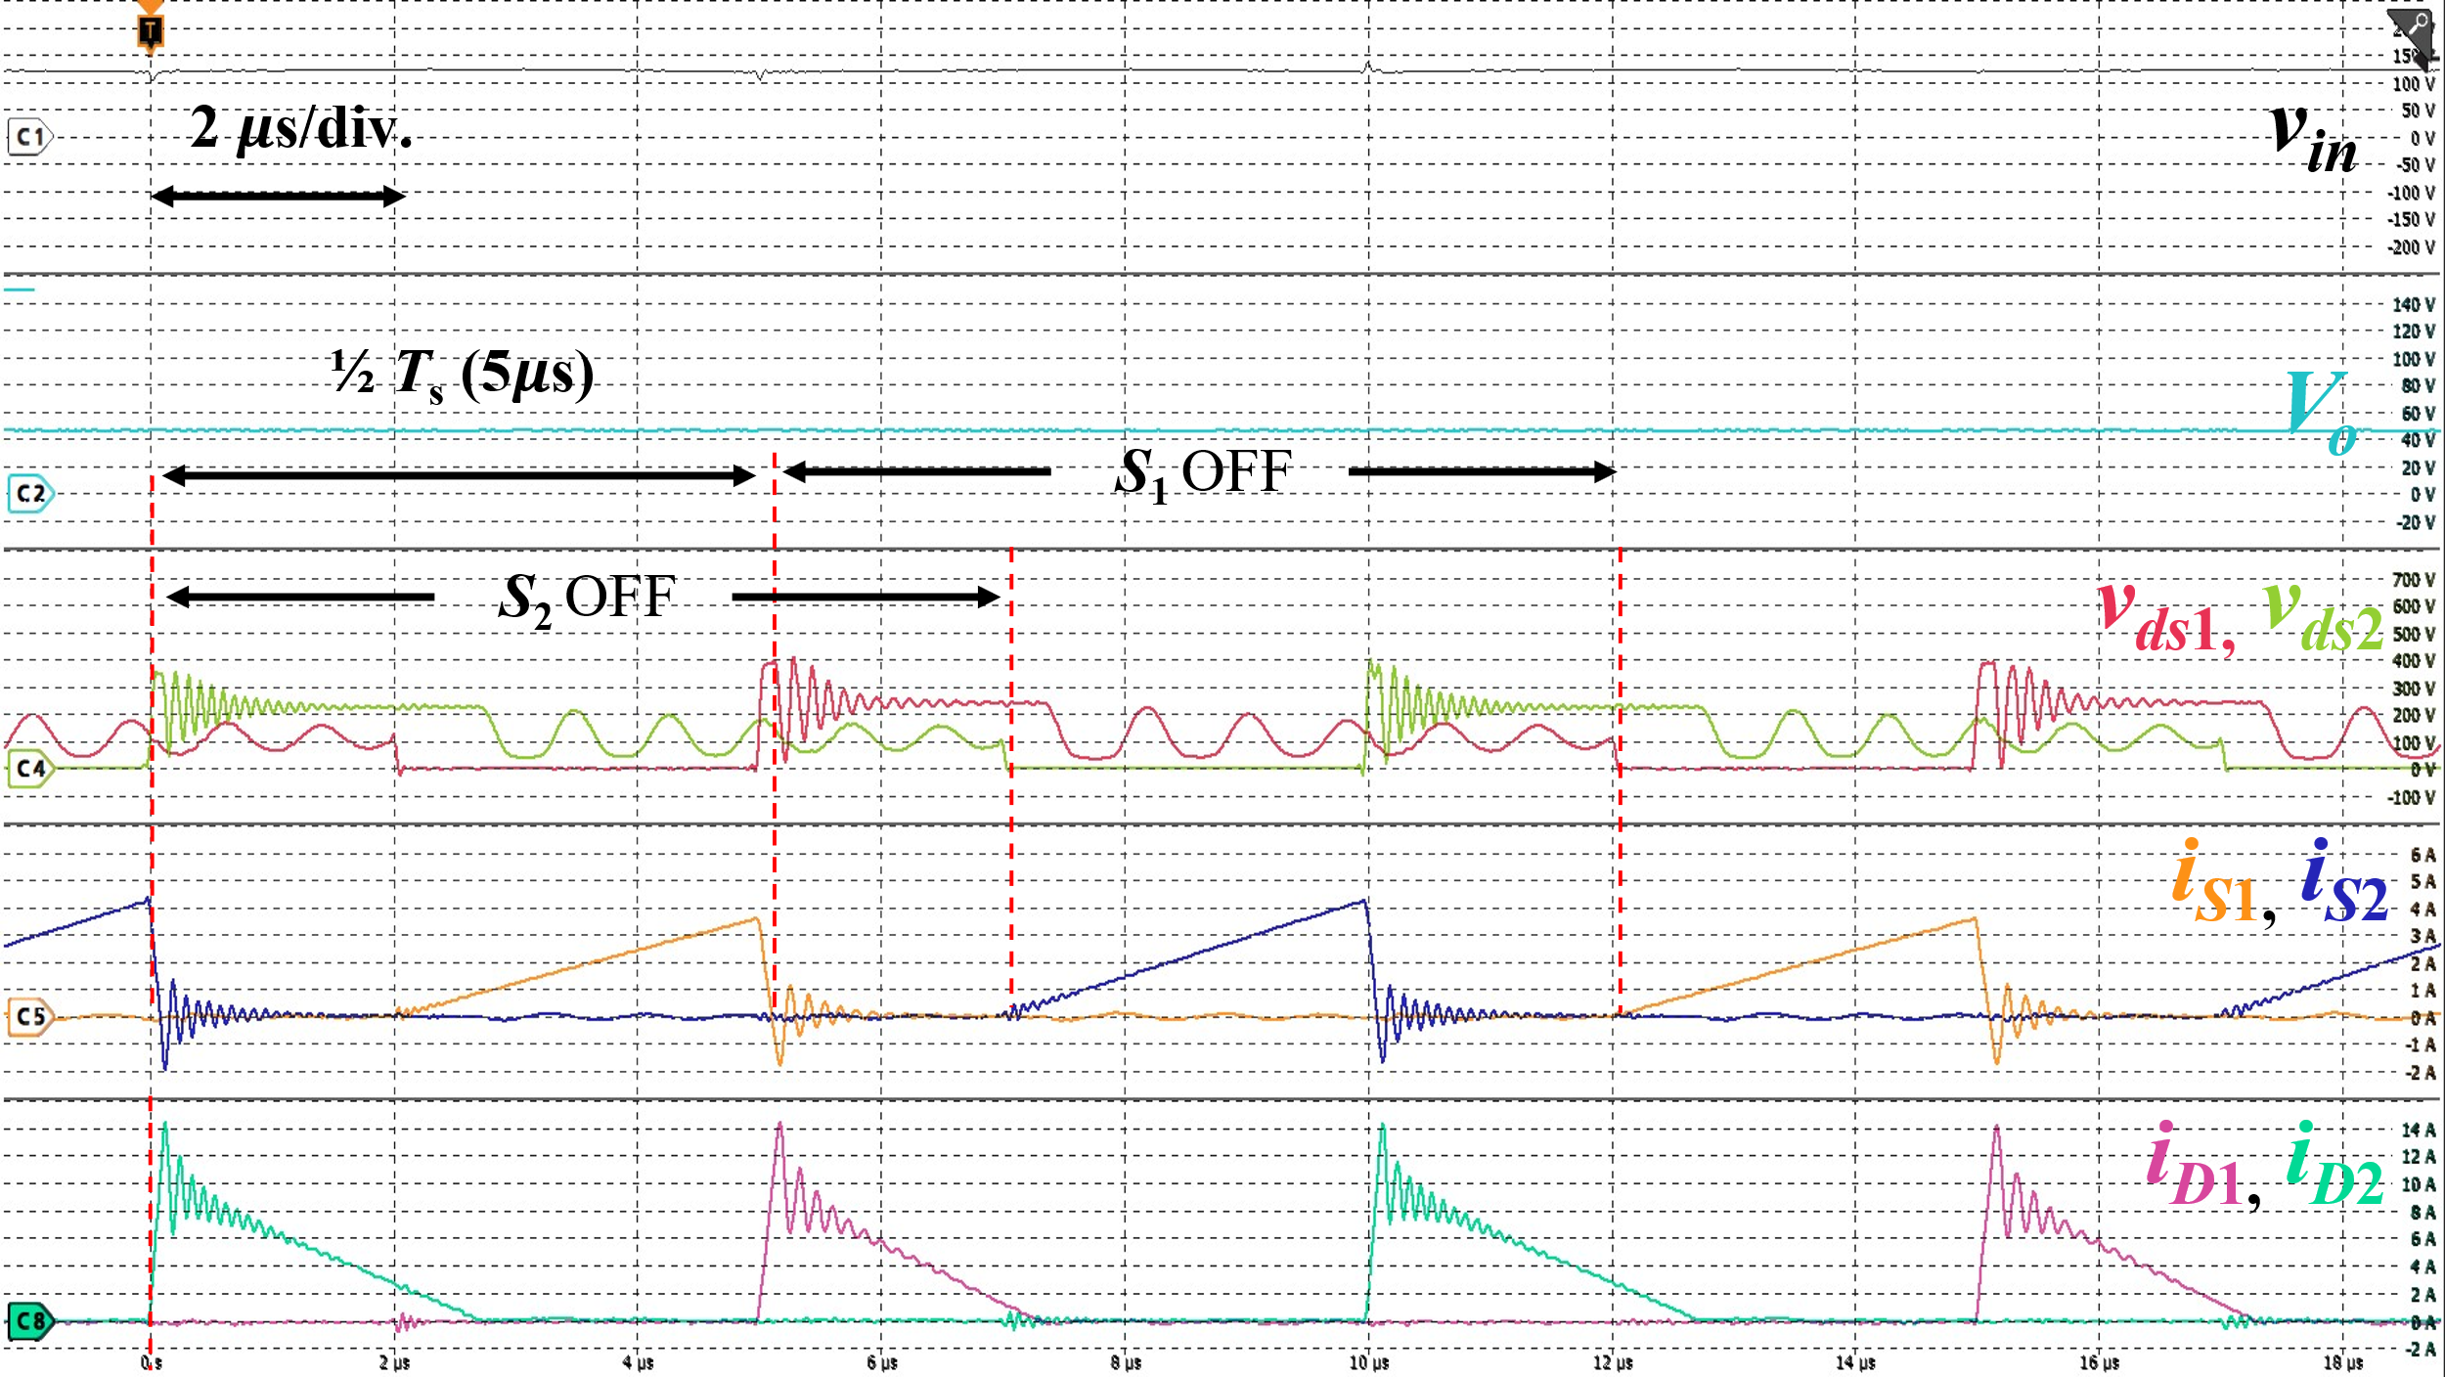  (b)  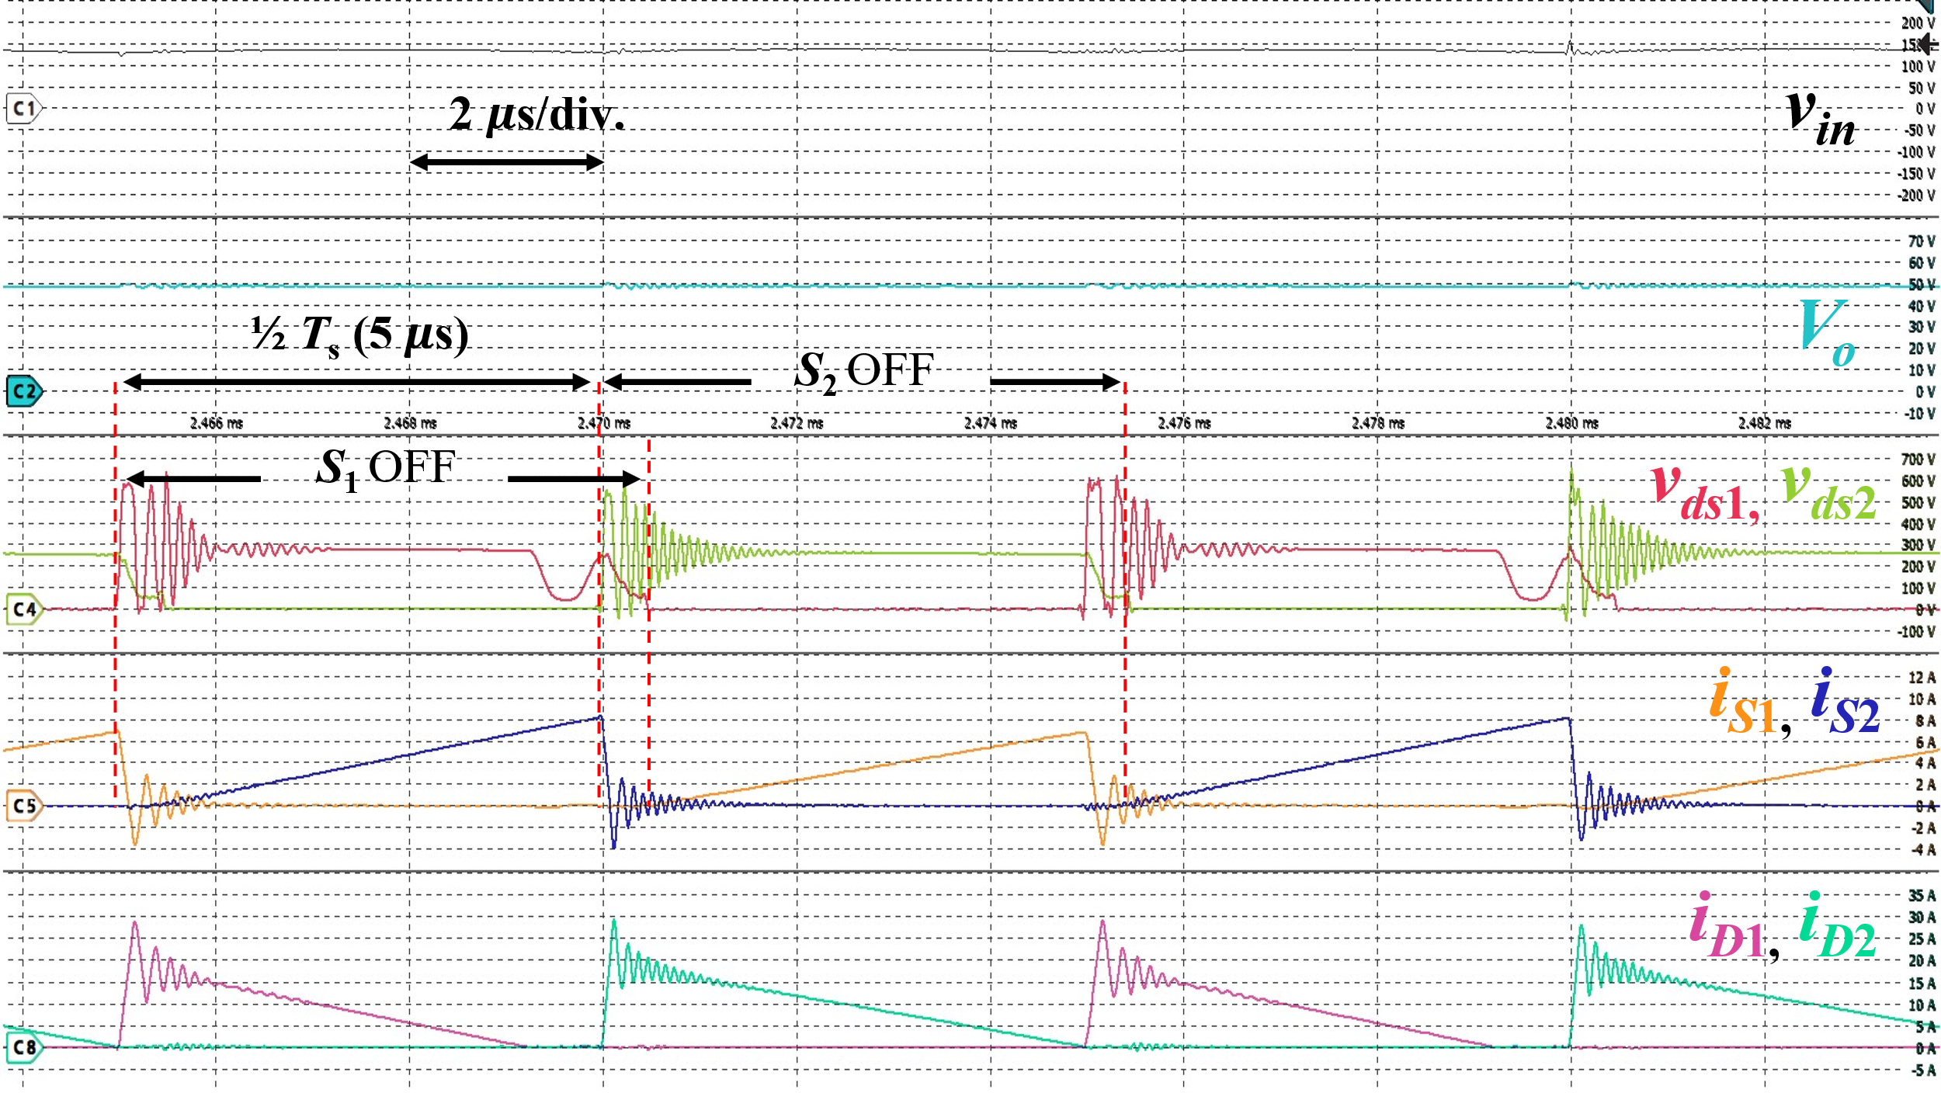  (c)  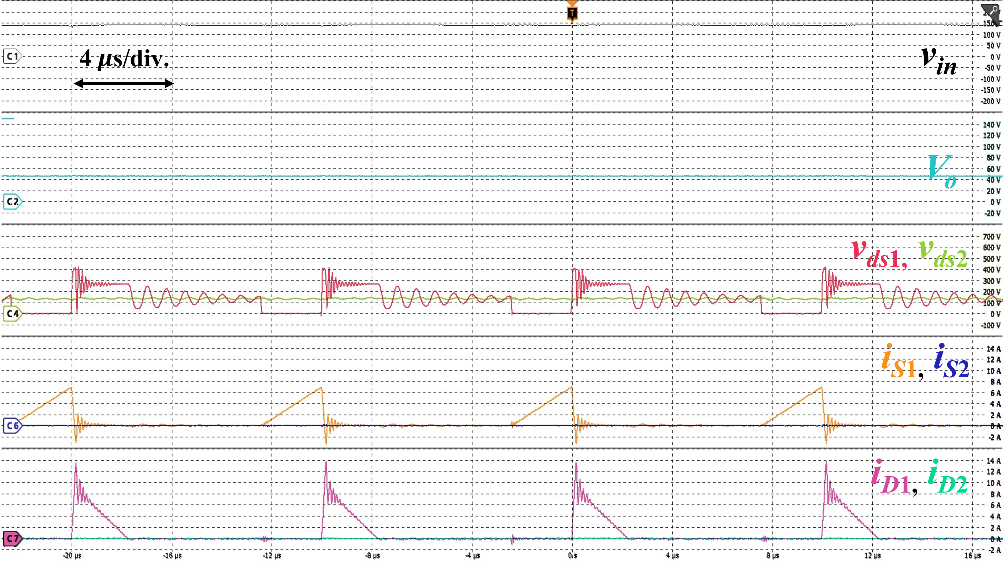  (d)  Fig. 17. Experimental waveforms of the proposed two-phase interleaved flyback rectifier at (a) and (b): 100 W, two-phase AC drive; (c): 240 W, two-phase AC drive; (d): 32.5 W, single-phase AC drive. For (a) and (b): $v_{in}$: 50 V/div., $V_{o}$: 10 V/div., $v_{ds1}$, $v_{ds2}$: 100 V/div., $i_{S1}$, $i_{S2}$: 1 A/div., $i_{D1}$, $i_{D2}$: 5 A/div.; For (c): $v_{in}$: 50 V/div., $V_{o}$: 10 V/div., $v_{ds1}$, $v_{ds2}$: 100 V/div., $i_{S1}$, $i_{S2}$: 2 A/div., $i_{D1}$, $i_{D2}$: 5 A/div.; For (d): $v_{in}$: 50 V/div., $V_{o}$: 20 V/div., $v_{ds1}$, $v_{ds2}$: 100 V/div., $i_{S1}$, $i_{S2}$: 2 A/div., $i_{D1}$, $i_{D2}$: 2 A/div. | (in Section V, Fig. 17)  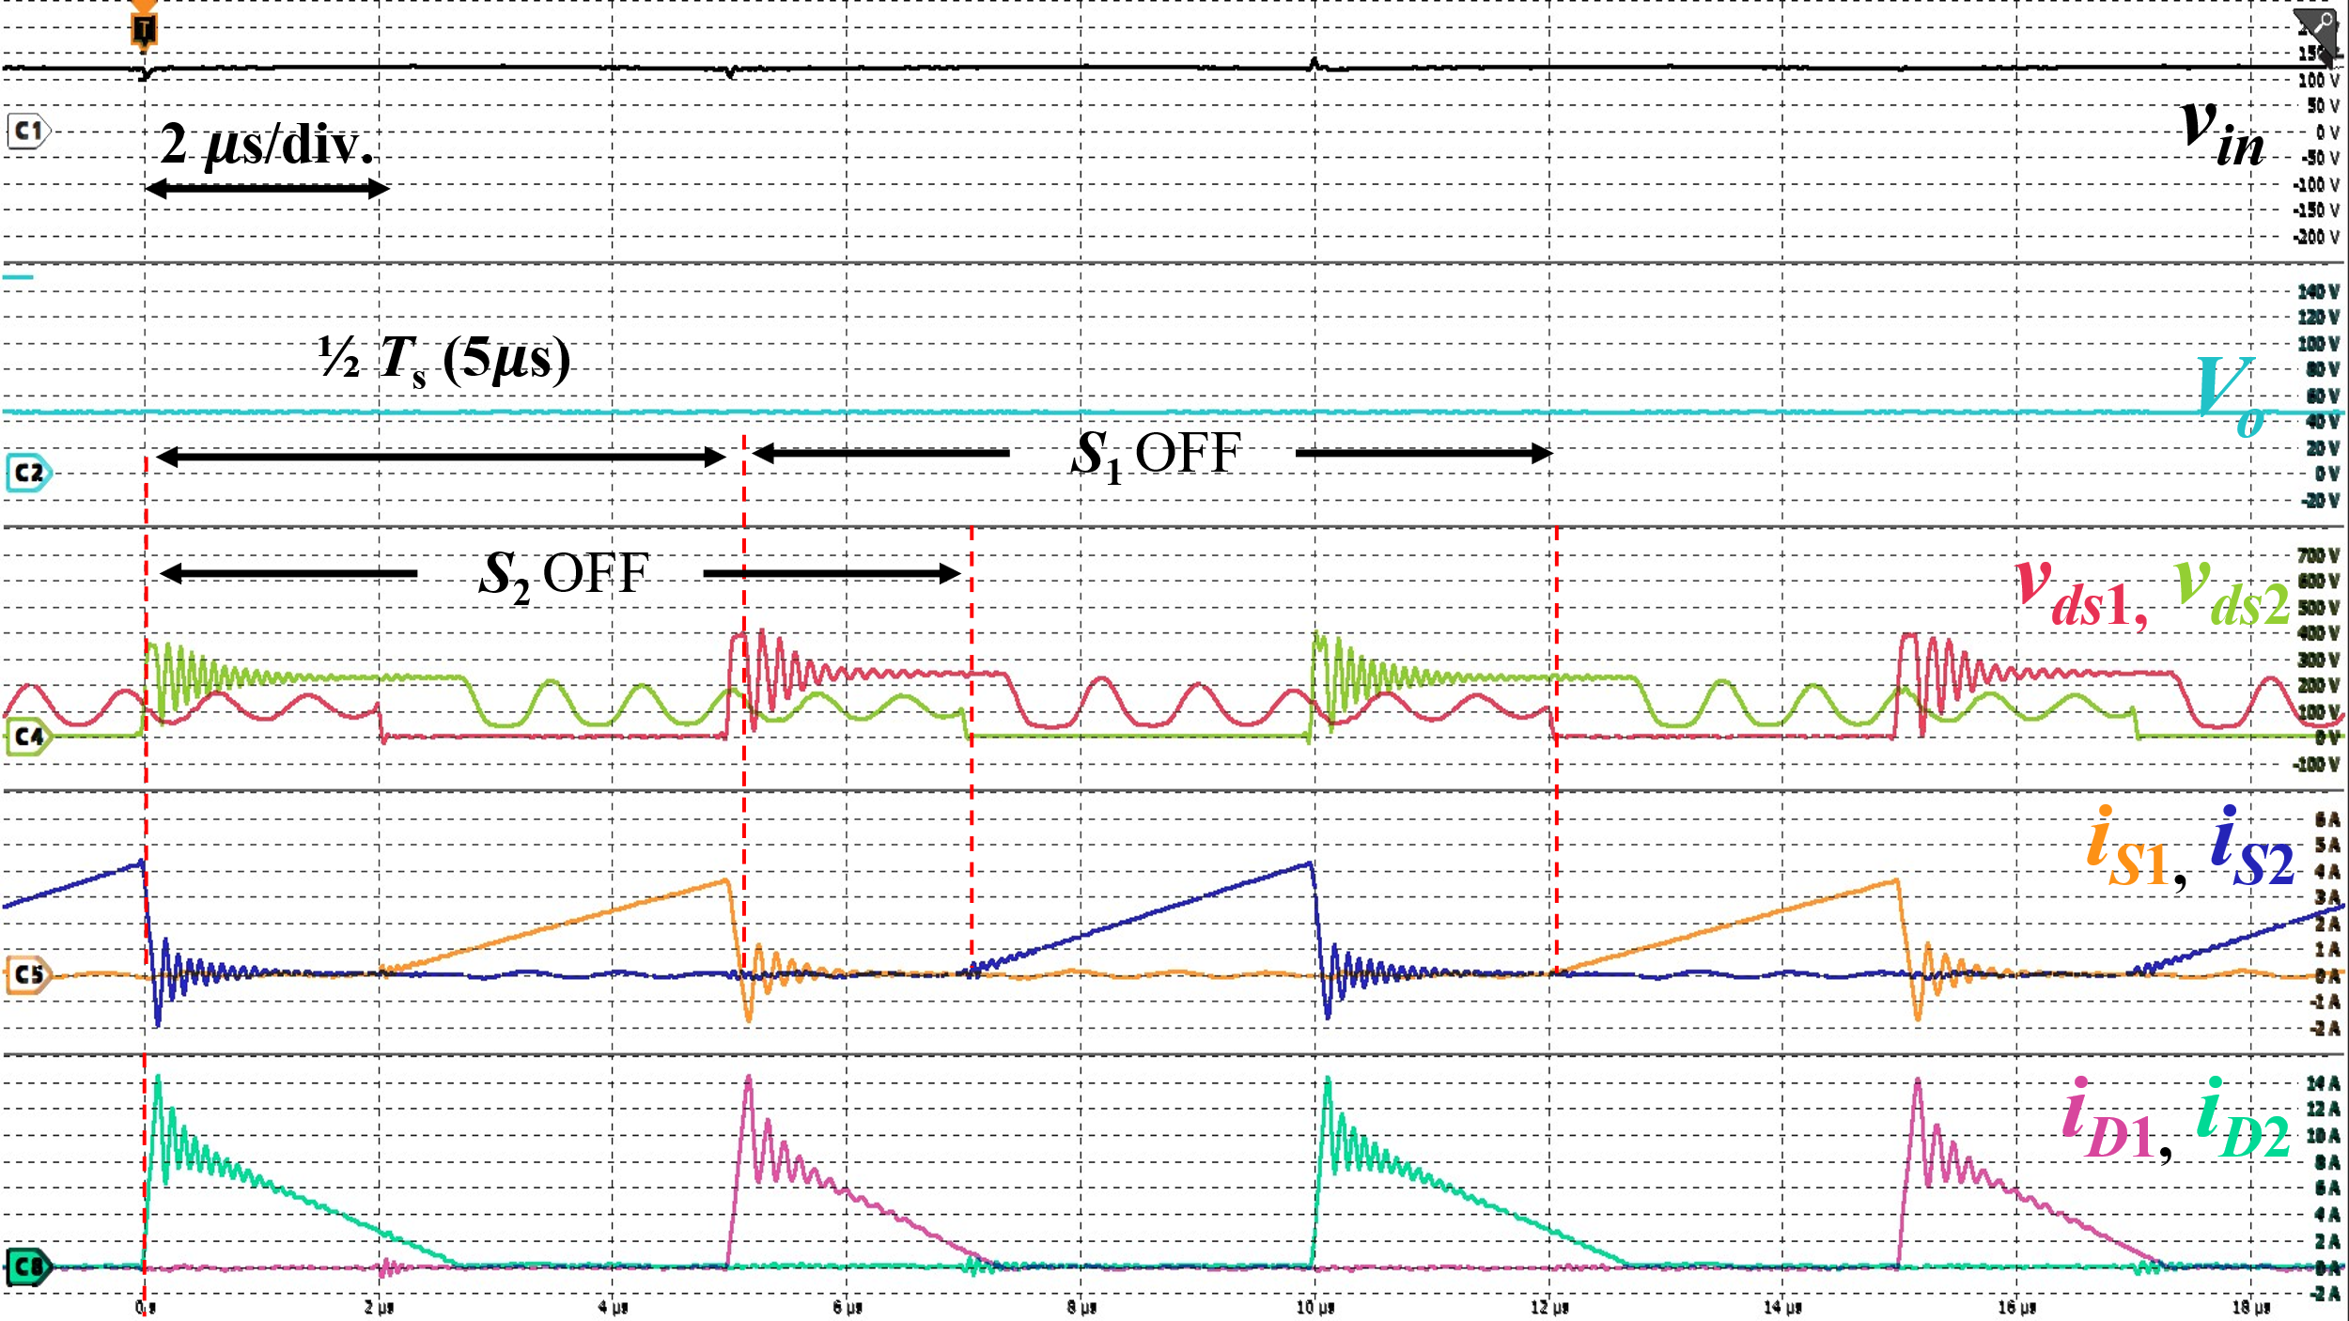  (b)  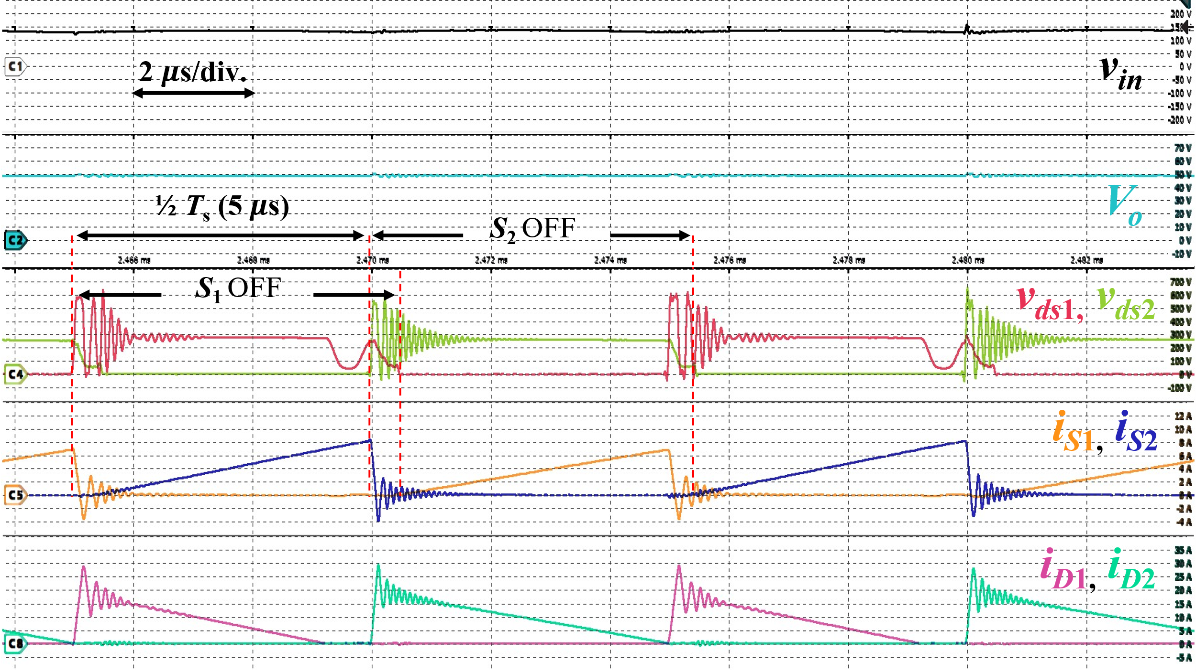  (c)  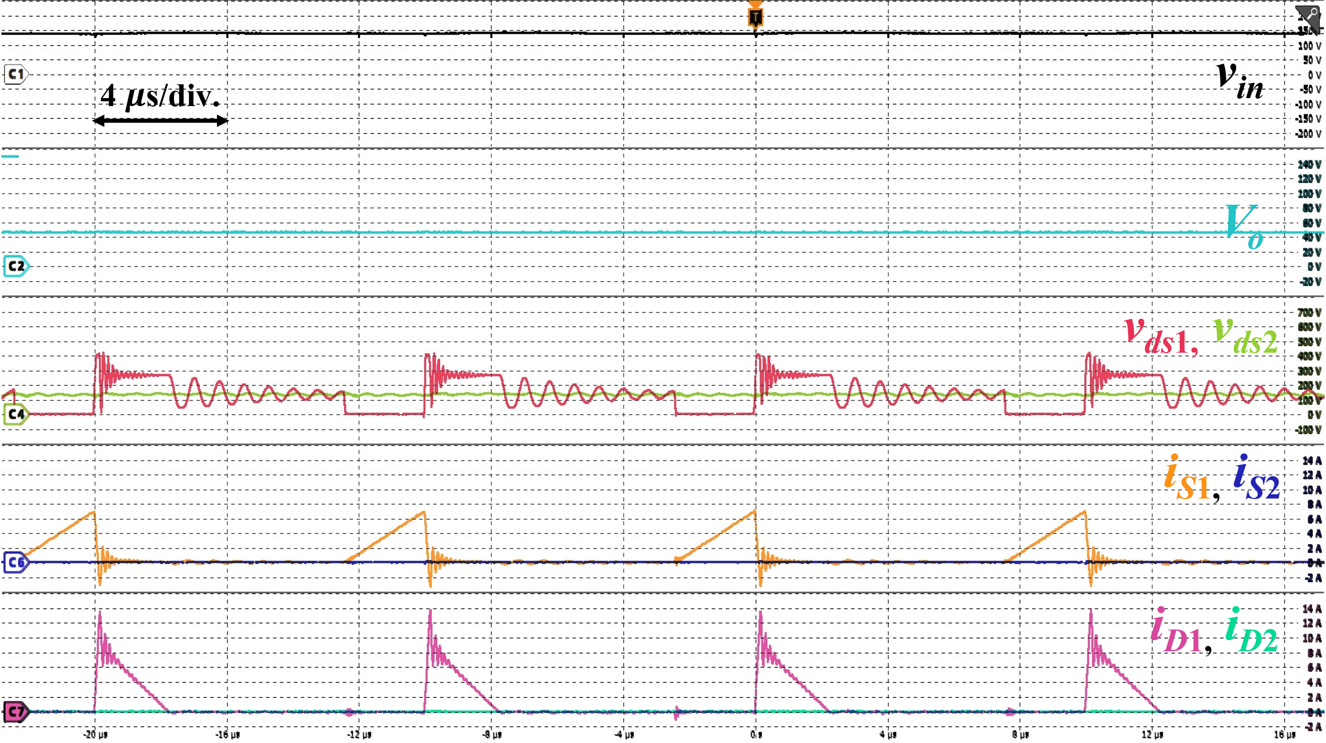  (d)  Fig. 17. Experimental waveforms of the proposed two-phase interleaved flyback rectifier at (a) and (b): 100 W, two-phase AC drive; (c): 240 W, two-phase AC drive; (d): 32.5 W, single-phase AC drive. For (a) and (b): $v_{in}$: 50 V/div., $V_{o}$: 10 V/div., $v_{ds1}$, $v_{ds2}$: 100 V/div., $i_{S1}$, $i_{S2}$: 1 A/div., $i_{D1}$, $i_{D2}$: 5 A/div.; For (c): $v_{in}$: 50 V/div., $V_{o}$: 10 V/div., $v_{ds1}$, $v_{ds2}$: 100 V/div., $i_{S1}$, $i_{S2}$: 2 A/div., $i_{D1}$, $i_{D2}$: 5 A/div.; For (d): $v_{in}$: 50 V/div., $V_{o}$: 20 V/div., $v_{ds1}$, $v_{ds2}$: 100 V/div., $i_{S1}$, $i_{S2}$: 2 A/div., $i_{D1}$, $i_{D2}$: 2 A/div.

Version 1
Before revision | After revision
(in Section V, Fig. 17)  (b)  (c)  (d)  Fig. 17. Experimental waveforms of the proposed two-phase interleaved flyback rectifier at (a) and (b): 100 W, two-phase AC drive; (c): 240 W, two-phase AC drive; (d): 32.5 W, single-phase AC drive. For (a) and (b): $v_{in}$: 50 V/div., $V_{o}$: 10 V/div., $v_{ds1}$, $v_{ds2}$: 100 V/div., $i_{S1}$, $i_{S2}$: 1 A/div., $i_{D1}$, $i_{D2}$: 5 A/div.; For (c): $v_{in}$: 50 V/div., $V_{o}$: 10 V/div., $v_{ds1}$, $v_{ds2}$: 100 V/div., $i_{S1}$, $i_{S2}$: 2 A/div., $i_{D1}$, $i_{D2}$: 5 A/div.; For (d): $v_{in}$: 50 V/div., $V_{o}$: 20 V/div., $v_{ds1}$, $v_{ds2}$: 100 V/div., $i_{S1}$, $i_{S2}$: 2 A/div., $i_{D1}$, $i_{D2}$: 2 A/div. | (in Section V, Fig. 17)  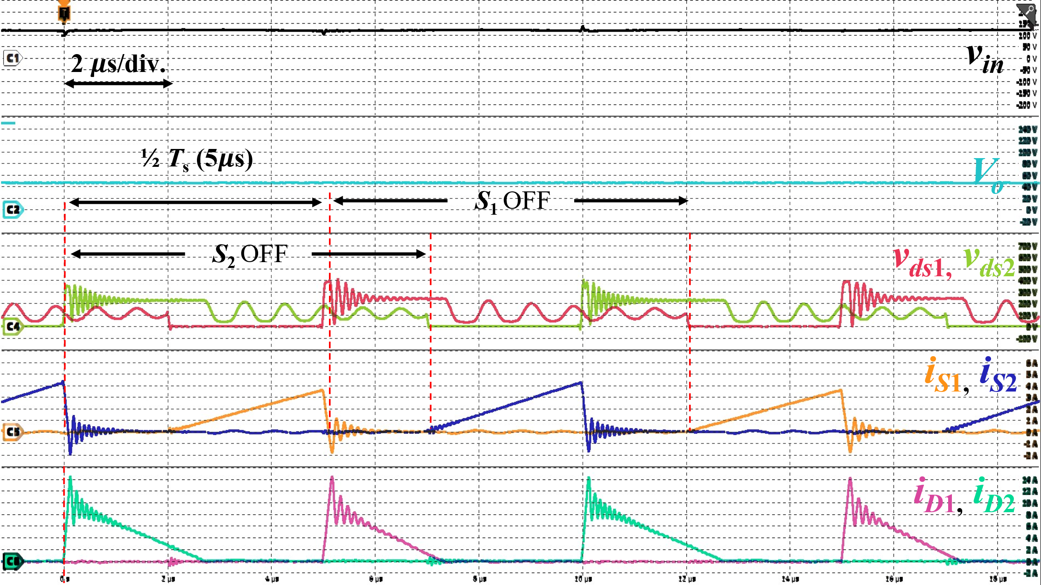  (b)  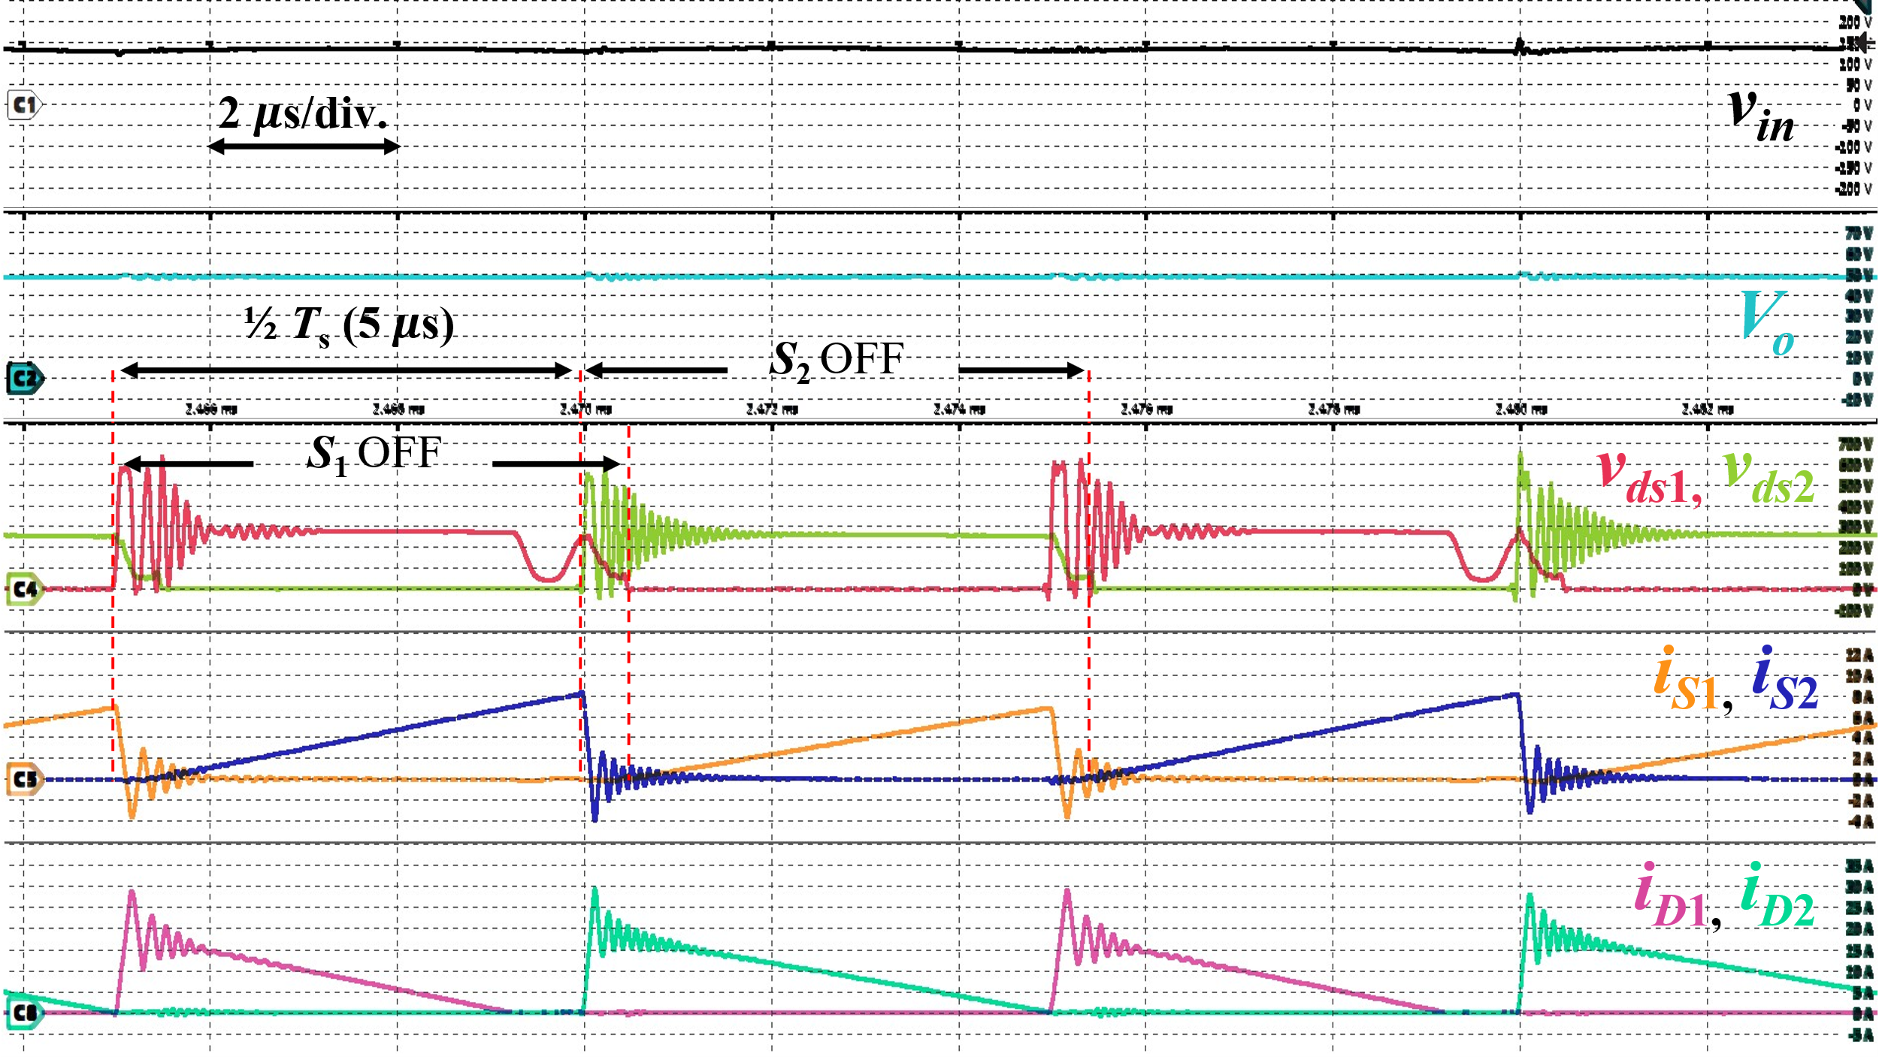  (c)  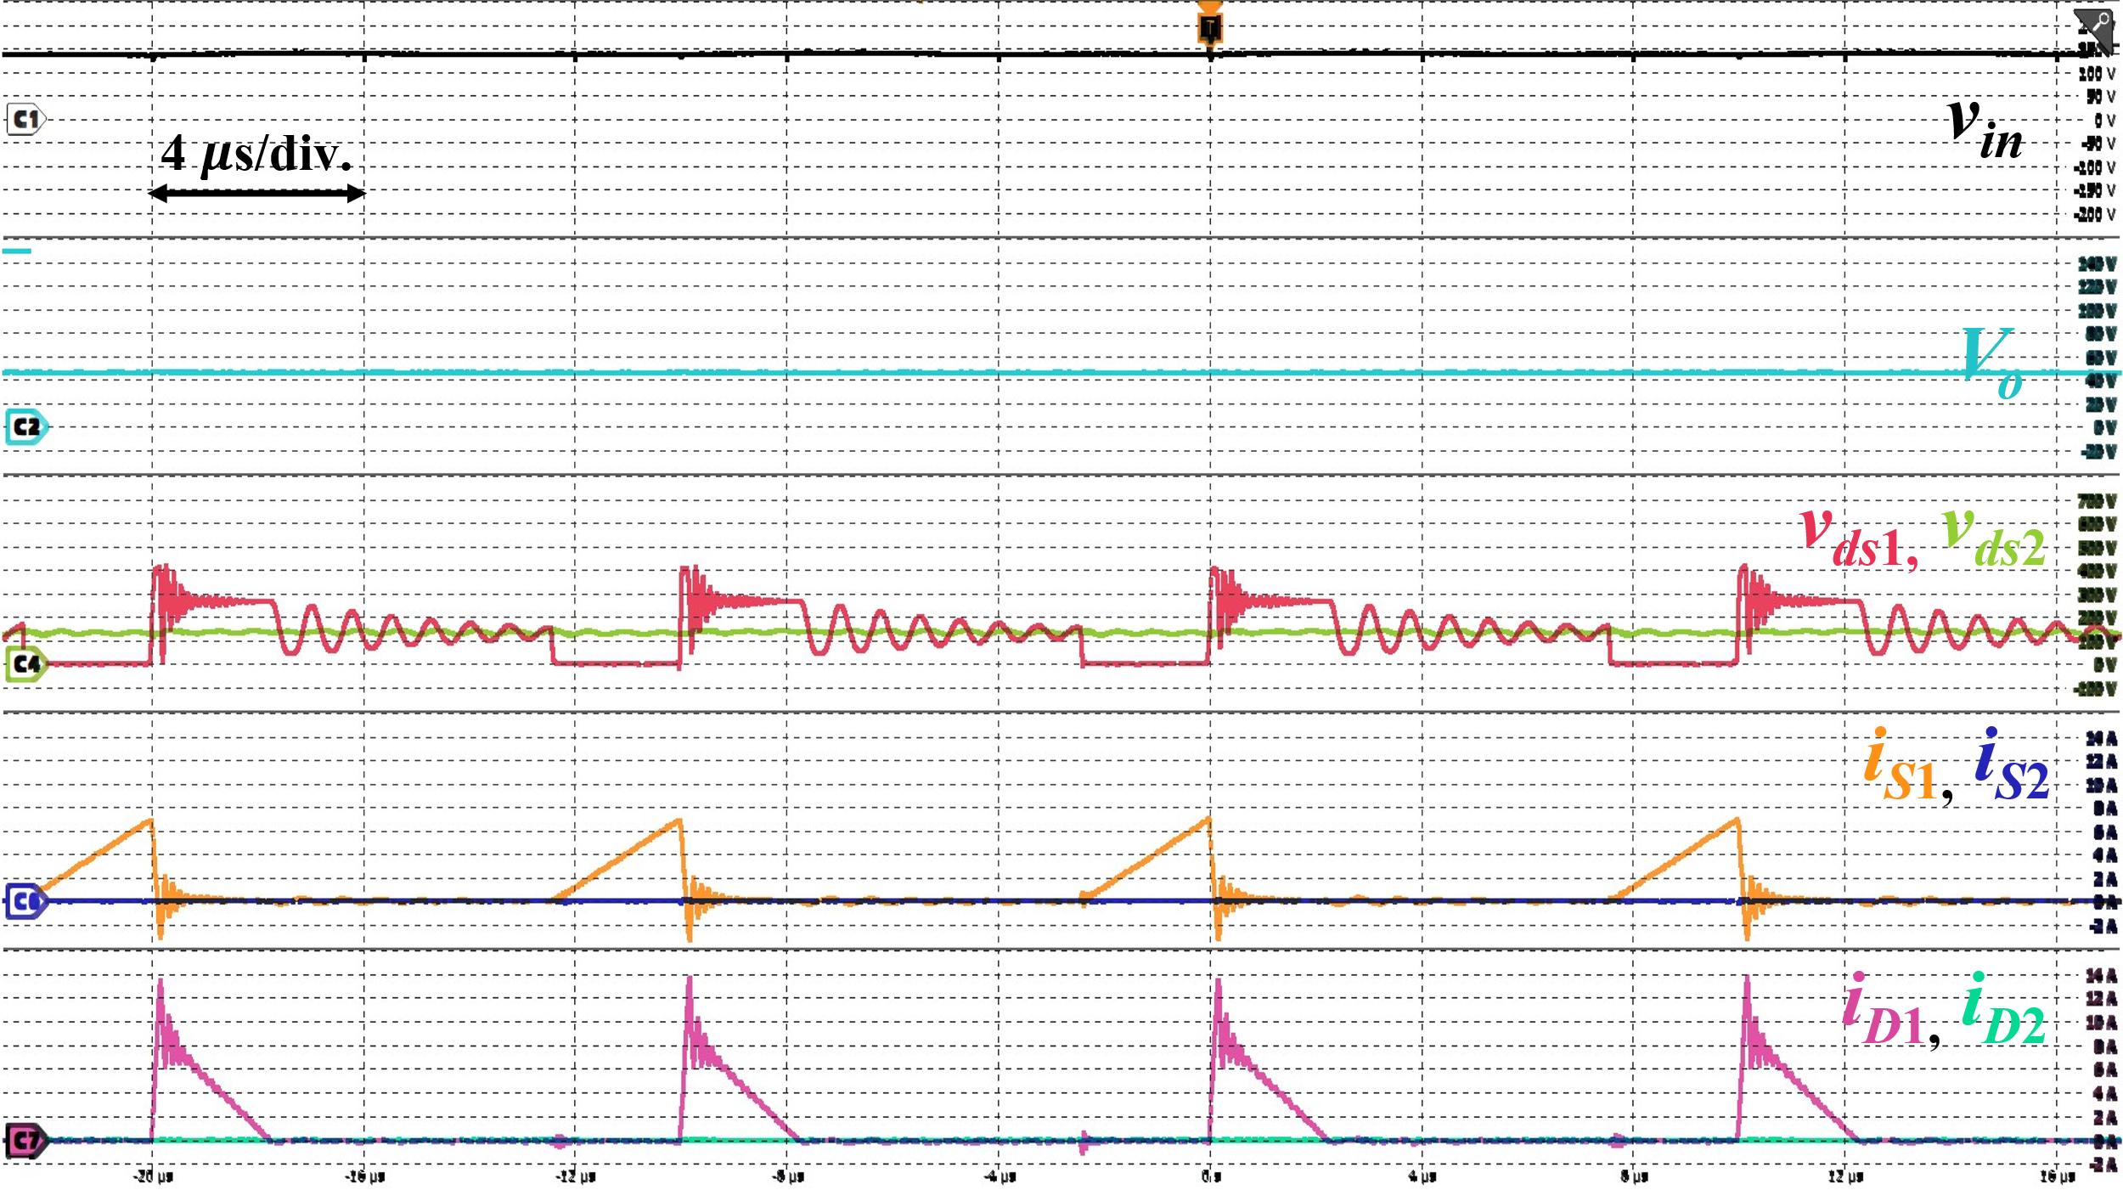  (d)  Fig. 17. Experimental waveforms of the proposed two-phase interleaved flyback rectifier at (a) and (b): 100 W, two-phase AC drive; (c): 240 W, two-phase AC drive; (d): 32.5 W, single-phase AC drive. For (a) and (b): $v_{in}$: 50 V/div., $V_{o}$: 10 V/div., $v_{ds1}$, $v_{ds2}$: 100 V/div., $i_{S1}$, $i_{S2}$: 1 A/div., $i_{D1}$, $i_{D2}$: 5 A/div.; For (c): $v_{in}$: 50 V/div., $V_{o}$: 10 V/div., $v_{ds1}$, $v_{ds2}$: 100 V/div., $i_{S1}$, $i_{S2}$: 2 A/div., $i_{D1}$, $i_{D2}$: 5 A/div.; For (d): $v_{in}$: 50 V/div., $V_{o}$: 20 V/div., $v_{ds1}$, $v_{ds2}$: 100 V/div., $i_{S1}$, $i_{S2}$: 2 A/div., $i_{D1}$, $i_{D2}$: 2 A/div.

To Reviewer 3
We authors appreciate your valuable comments. The revised parts are indicated by red texts in the manuscript.
Comments to the Author
This paper analyzes the design and implementation of an interleaved Flyback converter based on magnetic integration. My comments are as follows:
- The reviewers suggested including efficiency tests and comparing the results with other similar state-of-the-art topologies, but the authors did not adopt this recommendation.
- The efficiency curves provided in the authors' response are difficult to read due to the excessively wide range of the vertical axis. Furthermore, for an interleaved flyback converter, the prototype's efficiency is merely 85%—a figure far too low to meet the requirements for power electronic converters. While component selection certainly plays a significant role, the efficiency should not be this poor; such results suggest a fundamental flaw in the coupled transformer design or indicate that the topology itself may be incapable of achieving high efficiency.
We sincerely thank the reviewer for their critical feedback. Because Comments 1 and 2 both address the efficiency of the converter, we have combined our responses to address these concerns cohesively.

First, we apologize for the poor readability of the efficiency curve provided in our previous response. We have zoomed in the vertical axis of the plots and provided a zoomed in curve from 40 W to clearly display the data range. As measured using a Hioki PW8001 Power Analyzer, the efficiency peaks at approximately 84.6% near full load in two-phase drive. We present newly rescaled and zoomed-in figures here:

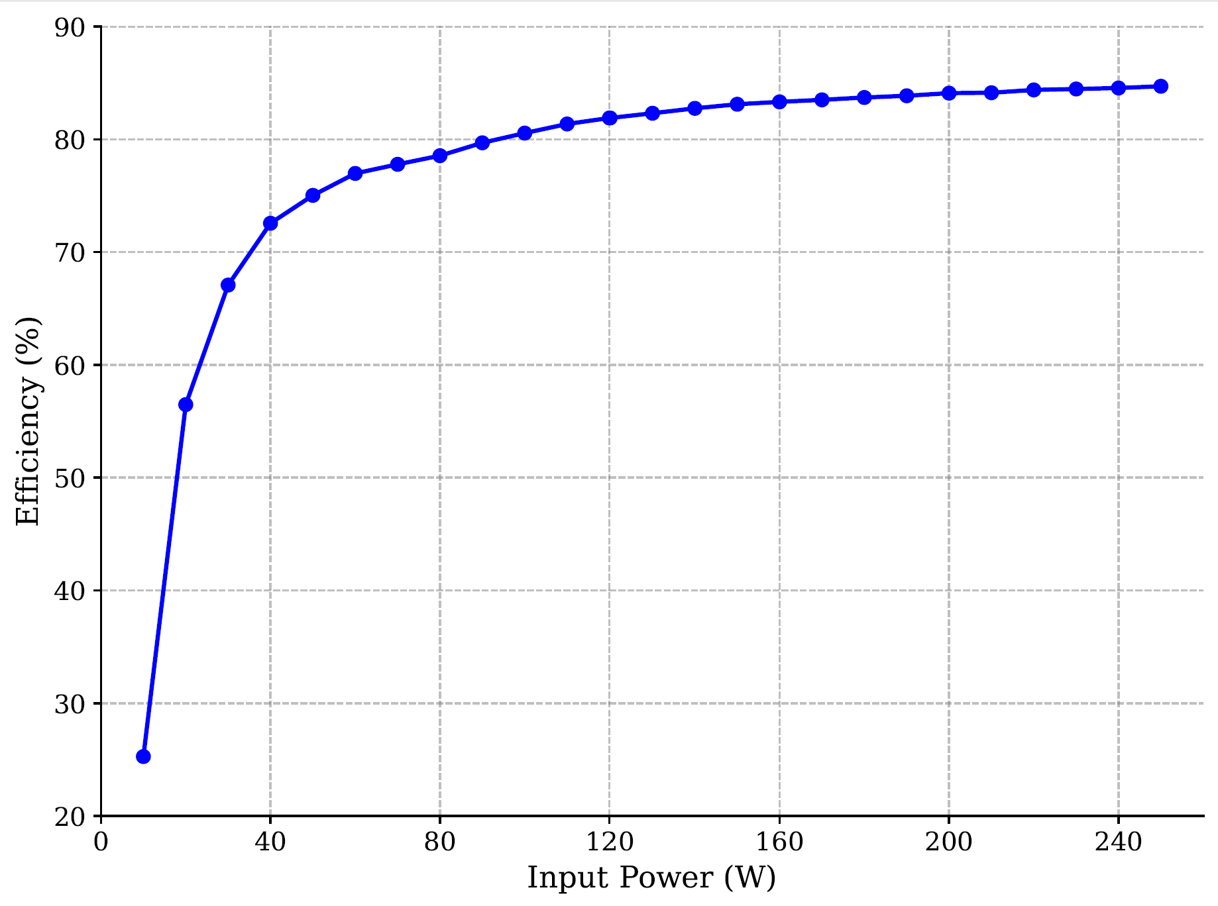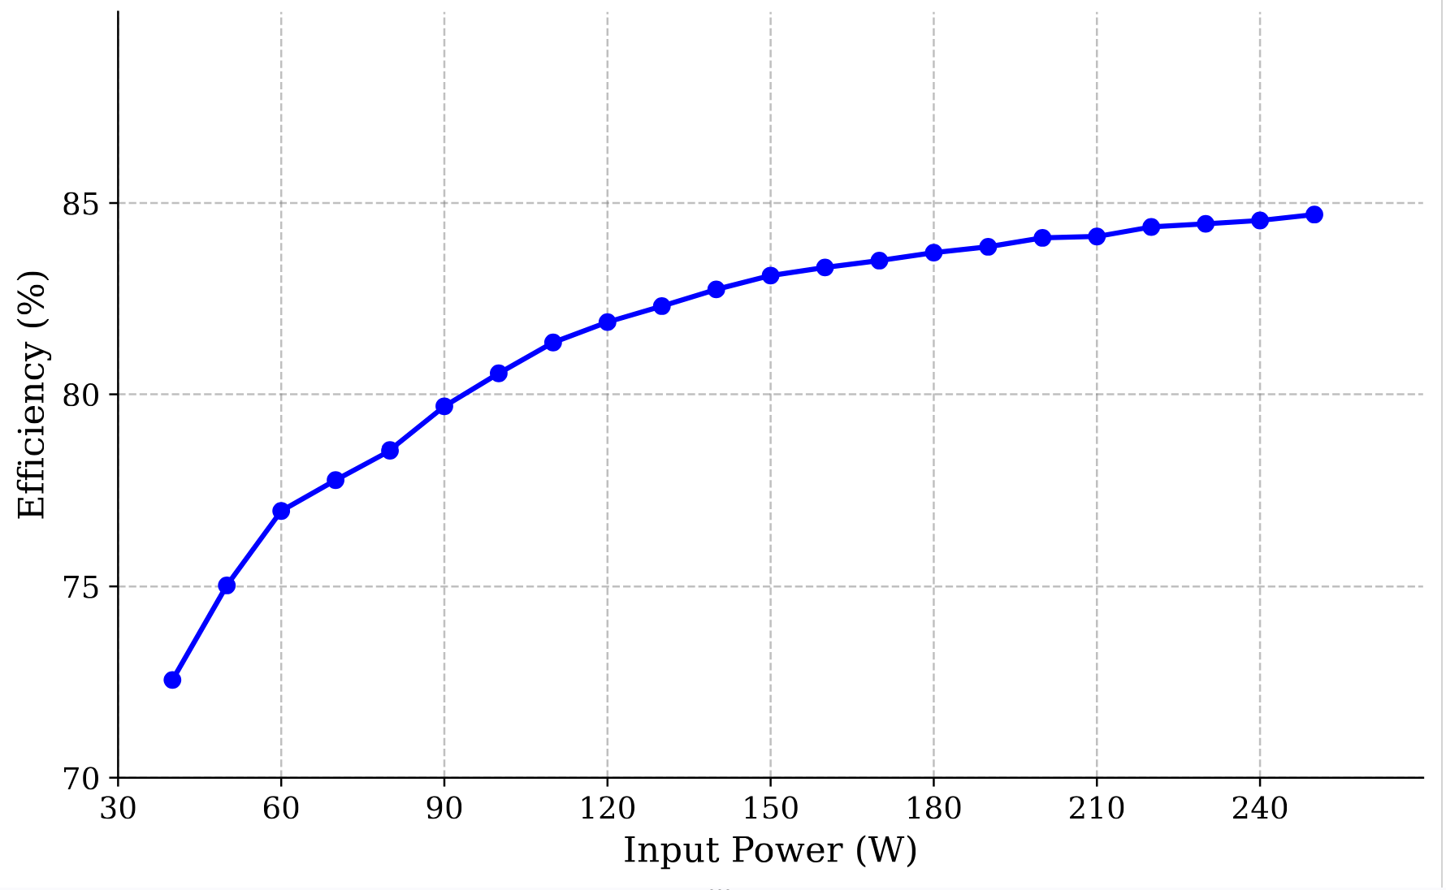
(a) (b)
(a) Efficiency curve across the entire load range, (b) efficiency curve from 40 W.

Regarding the concern that this efficiency indicates a fundamental flaw in the "coupled" transformer design, we respectfully wish to clarify two critical points regarding the topology and the scope of this research.

First, the proposed topology is explicitly decoupled (non-coupled). This magnetic decoupling within a single standard EE-core intentionally avoids the circulating currents across multi-phase operation that often limit traditional coupled designs.

Second, the ~85% efficiency is not indicative of a fundamental topological flaw, but rather a direct reflection of the specific hardware utilized for this proof-of-concept prototype. We would want to reiterate that the main focus of the paper is the design and experimental verification an integrated magnetic component capable of independent, two-phase operation due to magnetic decoupling. To ensure robust operation and protect the switches against surge voltages during these fundamental structural validations, standard RCD snubber circuits were utilized. Moreover, the magnetic component has not yet undergone comprehensive optimization. We anticipate that the overall system-level efficiency can be significantly improved in future iterations through the use of active clamp circuits, or advanced control techniques, and targeted magnetic optimization.

Within the specific domain of flyback converters in this power class, an efficiency of approximately 85% is entirely consistent: [1] achieves a maximum efficiency of 83%, [2] an efficiency of 85.4%, [3] an efficiency of 85%, [4] an efficiency of 80-85%, [5] an efficiency of 88%, [6] shows an efficiency of around 80-85% using RCD snubbers, and [7] shows an efficiency of around 82%.

Finally, regarding the recommendation to include an efficiency comparison with other similar state-of-the-art topologies, we respectfully maintain our stance. Experimental efficiencies across different literature prototypes are heavily influenced by the specific selection of semiconductor devices, topology configuration, control methods, and snubber optimizations. Because of these variables, direct efficiency comparisons are rarely fair or representative of the performance of the isolated component. Therefore, we have kept the manuscript focused strictly on the structural advantages of our approach.

References mentioned:

[1] Y. G. Kim et al., "Low-Cost Universal Multi-Mode Digital Compensator Design for Flyback Converters With Full Digital Feedback," in IEEE Access, vol. 12, pp. 170840-170850, 2024, doi: 10.1109/ACCESS.2024.3498032

[2] Analog Devices, Inc., "AD-PS3803-RD — System Level Documentation," Analog Devices System Level Documentation. [Online]. Available: https://analogdevicesinc.github.io/system-level/solutions/reference-designs/ad-ps3803-rd/. [Accessed: Oct. 24, 2026].

[3] S.-Y. Tseng and J.-H. Fan, "Buck-Boost/Flyback Hybrid Converter for Solar Power System Applications," Electronics, vol. 10, no. 4, p. 414, 2021, doi: 10.3390/electronics10040414.

[4] S. F. Graziani, T. V. Cook and B. M. Grainger, "Isolated Flying Capacitor Multilevel Converters," in IEEE Open Journal of Power Electronics, vol. 3, pp. 197-208, 2022, doi: 10.1109/OJPEL.2022.3160049.

[5] Y. -C. Li and C. -L. Chen, "A Novel Primary-Side Regulation Scheme for Single-Stage High-Power-Factor AC–DC LED Driving Circuit," in IEEE Transactions on Industrial Electronics, vol. 60, no. 11, pp. 4978-4986, Nov. 2013, doi: 10.1109/TIE.2012.2224080.

[6] P. Thummala, H. Schneider, Z. Zhang, Z. Ouyang, A. Knott and M. A. E. Andersen, "Efficiency Optimization by Considering the High-Voltage Flyback Transformer Parasitics Using an Automatic Winding Layout Technique," in IEEE Transactions on Power Electronics, vol. 30, no. 10, pp. 5755-5768, Oct. 2015, doi: 10.1109/TPEL.2014.2379439.

[7] Y. -C. Li and C. -L. Chen, "A Novel Primary-Side Regulation Scheme for Single-Stage High-Power-Factor AC–DC LED Driving Circuit," in IEEE Transactions on Industrial Electronics, vol. 60, no. 11, pp. 4978-4986, Nov. 2013, doi: 10.1109/TIE.2012.2224080.

- The paper should present PFC voltage and current waveforms to substantiate the power factor claims. Typically, an uncontrolled rectifier with capacitive filtering yields a power factor of only 0.6–0.7 in the absence of PFC modulation.
We sincerely thank the reviewer for the valuable feedback and for acknowledging the clarity of our analytical explanation. We completely agree that the power factor $PF$ and input-current THD are critical metrics for PFC flyback rectifiers. However, because the inherent DCM PFC mechanism is already a well-known and established characteristic, our physical prototype was constructed without a grid-side EMI filter to focus strictly on validating the magnetic decoupling of the proposed integrated core. We would also like to emphasize that the proposed magnetic integration does not alter the fundamental electrical principle of the converter. The inherent DCM PFC mechanism remains identical to that of a conventional topology utilizing discrete transformers. To rigorously demonstrate this, we have conducted a comprehensive open-loop simulation in PLECS with a standard differential-mode EMI filter ($L_{f}=100 \text{μ}\text{H}$, $C_{f}=1 \text{μ}\text{F}$) to obtain an accurate estimate.

Moreover, the proposed integrated transformer design was compared against a conventional, interleaved flyback baseline with two discrete cores. The cross-sectional area of these discrete cores was matched to the smaller outer leg of the proposed design ($A_{mo}=117.624{\text{ mm}}^{2}$). Both setups were assigned identical turns ratios (18:6) to the center leg of the proposed transformer, and air gaps were tuned to maintain the exact same nominal magnetizing inductance $L_{m}$. The magnetic path length was set to $66.21\text{ mm}$, and the air gap was set to 0.677 mm. Magnetic circuit models were utilized reflecting these parameters.

As shown in the table below, the proposed topology exhibits PF and input-current THD performance that is closely matched to the conventional discrete setup across the extremes of the operating range. This also confirms that the magnetic integration successfully preserves the PFC capability of the converter, given that PF > 0.97 across different operating points.

We have added PFC waveforms as well in various operating points for a visual reference for the reviewers. We have revised Section III completely to reflect these changes.

(a) (b)
Key PFC Waveforms showing v_{in}, v_{o}, i_{in}, i_{S1} and i_{S2}, and v_{ds1} and v_{ds2} with v_{in}, V_{out}, and P_{O} of: (a) 100 V_{rms}, 48 V, and 240 W and (b) 240 V_{rms}, 48 V, and 240 W.

- End of the response letter-

